Inquiry Lab Activity Sheet
Sometimes You Behave like a WAVE, sometimes you Don’t! -
An Exploration of EM Radiation at Cornell

Objectives:
- Explain the duality of EM radiation with simple intelligence, (non-scientist would understand).
- Express an interest in further studies of Quantum Mechanics including matter waves.
- Consider research as a component of their future education and careers.

Vocabulary:
Quantum Mechanics
Electromagnetic Spectrum
Constructive Interference
Destructive Interference
Diffraction
Photon
DeBroglie Wavelength (Matter Waves)
Heisenberg Uncertainty Principle

Materials:
Glass slide, candle, matches, Laser pointer, Laser pointer tripod, digital vernier calipers, & safety pin

Safety: Be cautious with the candle and the glass. Assume glass is HOT because it looks the same hot or cold!
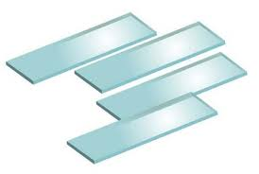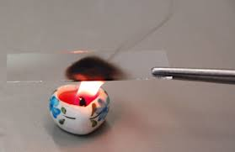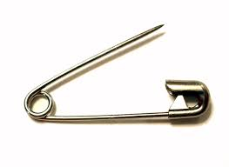

Procedure:
- Individually consider and respond in writing to this question: “How do we modify light for scientific observations and demonstrate duality?”
- Gently grab and hold the glass slide with tweezers. Ignite a match and light your candle. Safely apply a layer of carbon to your glass slide from the open flame.
- Skillfully etch into the carbon layer double-slit, single hole, and single slit patterns as shown.
- Use your optical interference Pattern on glass slides to explore the dual nature of the electromagnetic spectrum. Share out results as a team with the rest of the class.
- Complete an Exit Survey.

Observations and Results:
Consider the following quote and describe your Patterns from left to right. Be sure and chose Wave or Particle nature as the more obvious for each.

“I will not describe it in terms of an analogy with something familiar. I will simply describe it.”

Richard Feynman at Cornell Character of Physical Law Lecture, 1964

P1 | P2 | P3 | P4 | P5 | P6 | P7 | P8 | P9 | P10 | P11 | P12

Conclusion: Explain the dual nature of matter and light as if you were trying to convince a skeptic that both exist in nature.

