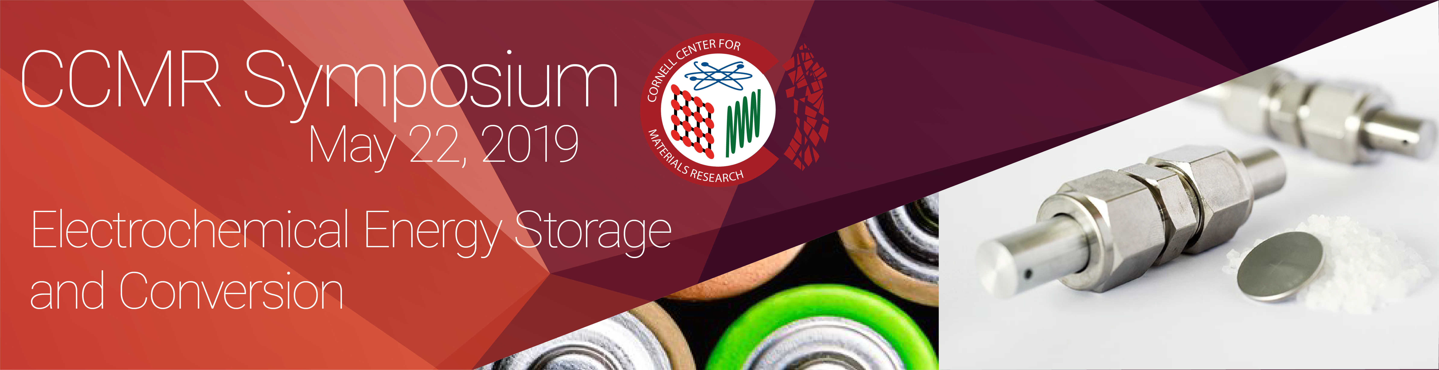

120 Physical Sciences Building (PSB), Cornell University

Wednesday May 22

8:00 – 8:30 am Breakfast & Registration – PSB Clark Atrium

8:30 – 9:00 am Welcome Remarks and Introduction – 120 PSB
Prof. Frank Wise, Director, CCMR; with the Symposium Organizing Committee: Profs. Yong Joo, Chemical and Biomoelecular Engineering, and Jin Suntivich, Materials Science and Engineering, Cornell University

9:00 – 10 am Sproull Lecture – Materials Science for Better Batteries. Achievements and New Directions
Prof. Jean-Marie Tarascon, Solid State Chemistry and Energy, Collège de France

10:00 – 10:30 am The Pursuit and Discovery of Vehicle Electrification Markets using Lithium-ion and/or Fuel Cell Powertrains
Prof. Mark Mathias, Chemical Engineering, University of Rochester

10:30 – 10:45 am Coffee Break & Posters – PSB Clark Atrium

10:45 – 11:15 am Beyond Platinum Alloy Cathode Catalysts for Polymer Electrolyte Fuel Cells.
Dr. Deborah Myers, Hydrogen and Fuel Cells Materials Group, Argonne National Laboratory

11:15 – 11:45 am The Importance of Materials Porosity in Fuel Cell Performance at High Power and Use of Hydrogen Fuel Cells in Unmanned Air Vehicles
Dr. Karen Swider Lyons, Director, Laboratory for Autonomous Systems Research, US Naval Research Laboratory

11:45 – 1:15 pm Lunch and Poster Session – PSB Clark Atrium

1:15 – 1:45 pm Designing Electrolytes and Interphases for Lithium Batteries
Prof. Lynden Archer, Chemical and Biomolecular Engineering, Cornell University; and Founder and Board Member of NOHMs, Rochester, NY

1:45 – 2:15 pm How Far Can We Push the Limits of Intercalation Batteries
Prof. Stanley Whittingham, Chemistry and Materials Science and Engineering, SUNY at Binghamton

2:15 – 2:30 pm Coffee Break & Posters – PSB Clark Atrium

2:30 – 3:00 pm Safe and Highly Conductive Electrolytes: From Liquid to Solid
Dr. Andreas Hintennach, Group Research, Daimler AG

3:00 – 3:30 pm Title
Dr. Derek C. Johnson, Global R&D, A123 Systems, LLC

3:30– 3:45 pm Wrap up

3:45 – 5:30 pm Poster Session and Reception - Baker Portico

