2019 CCMR Symposium – May 22, 2019
Sproull Lecturer:  Prof. Jean-Marie Tarascon  Solid State Chemistry and Energy, Collège de France | Dr. Karen Swider Lyons  Director, Laboratory for Autonomous Systems Research  US Naval Research Laboratory
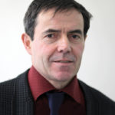 | 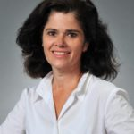
Dr. Deborah Myers  Hydrogen and Fuel Cell Materials Group  Argonne National Laboratory | Dr. Andreas Hintennach  Group Research  Daimler AG.
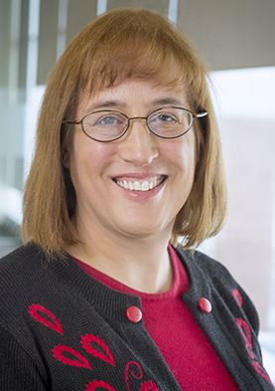 | 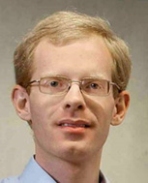
Prof. Lynden Archer  Chemical and Biomolecular Engineering  Cornell University  Co-Founder of NOHMs, Rochester, NY | Prof. Stanley Whittingham  Chemistry and Materials Science and Engineering  SUNY at Binghamton
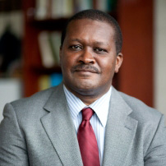 | 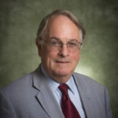
Prof. Mark Mathias  Chemical Engineering  University of Rochester | Dr. Derek Johnson  VP, Global R&D  A123 Systems, LLC
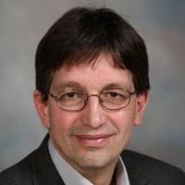 | 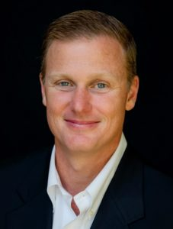

2019 Organizing Committee:

Prof. Jin Suntivich, Materials and Engineering Physics, Cornell University
Prof. Yong Joo, BP Amoco/H. Laurance Fuller Professor, Chemical and Biomolecular Engineering, Cornell University

