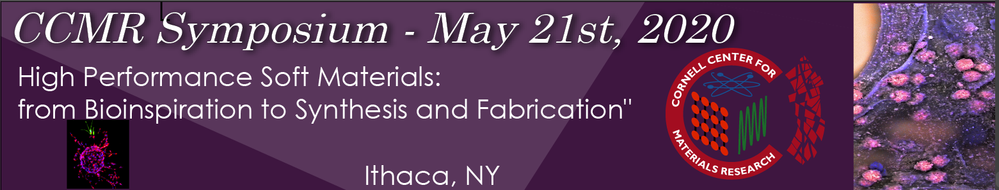

120 Physical Sciences Building (PSB), Cornell University

Wednesday May 21, 2020

8:00 – 8:30 am Breakfast & Registration – PSB Clark Atrium

8:30 – 9:00 am Welcome Remarks and Introduction – 120 PSB
Prof. Frank Wise, Director, CCMR; with the Symposium Organizing Committee: Prof. Lawrence Bonassar, Meinig School of Biomedical Engineering/Sibley School of Mechanical and Aerospace Engineering, and Prof. Nikolaos Bouklas, Sibley School of Mechanical and Aerospace Engineering, College of Engineering, Cornell University.

9:00 – 10 am Sproull Lecture – Title
Prof. Mooney, Robert P. Pinkas Family Professor of Bioengineering; Core Faculty Member, Wyss Institute for Biologically Inspired Engineering, Harvard University.

10:00 – 10:15 am Title
Dr. Dan Cohen, CEO, 3DBio Corporation

10:15 – 10:30 am Title
Dr. Radislav Potyrailo, Principal Scientist, Micro & Optoelectronics, GE Research

10:30 – 10:45 am Coffee Break & Posters – PSB Clark Atrium

10:45 – 11:00 am Title.
Dr. Carl Flannery, Director of Scientific Affairs, Bioventus, LLC

11:00 – 11:25 am Title
Prof. Jeffrey S. Moore, Professor of Chemistry and Howard Hughes Medical Institute Professor, University of Illinois

11:25 – 11:50 am Title
Prof. Shaoyi Jiang, Chemical Engineering, University of Washington;

11:50 – 1:15 pm Lunch and Poster Session – PSB Clark Atrium

1:15 – 1:40 pm Title
Dr. Nakhiah Goulbourne, Program Director, Civil, Mechanical & Manufacturing Innovation, National Science Foundation

1:40 – 2:05 pm Title
Dr. Richard Vaia, Senior Technologist, Air Force Research Laboratory.

2:05 – 2:20 pm Coffee Break & Posters – PSB Clark Atrium

2:20 – 2:45 pm Title
Prof. Xuanhe Zhao, Mechanical Engineering, MIT

2:45 – 3:10 pm Title
Dr. Arthur Woll, Director, The Materials Solutions Network at CHESS (MSN-C), Cornell University

3:10– 3:20 pm Wrap up

3:20 – 5:30 pm Poster Session and Reception - Baker Portico

