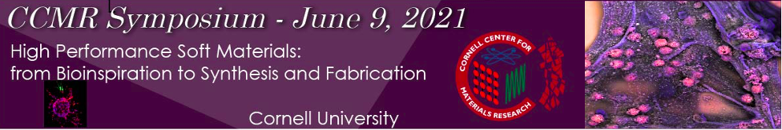

8:45 – 9:00 am Welcome Remarks and Introduction
Prof. Frank Wise, Director, CCMR; with the Symposium Organizing Committee: Prof. Lawrence Bonassar, Meinig School of Biomedical Engineering/Sibley School of Mechanical and Aerospace Engineering, and Prof. Nikolaos Bouklas, Sibley School of Mechanical and Aerospace Engineering, College of Engineering, Cornell University.

9:00 – 10 am Sproull Lecture – From Cells to Medical Adhesives.
Prof. David Mooney, Robert P. Pinkas Family Professor of Bioengineering; Core Faculty Member, Wyss Institute for Biologically Inspired Engineering, Harvard University.

10:00 – 10:20 am 3D-bioprinting of living tissues for therapeutics.
Dr. Dan Cohen, CEO, 3DBio Corporation

10:20 – 10:40 am Bioinspired Sensors: New Design Rules and Fabrication Processes to Meet Demanding Contemporary Gas-Sensing Needs.
Dr. Radislav Potyrailo, Principal Scientist, Micro & Optoelectronics, Gas-Chem-Bio Sensors & Systems, GE Research

10:40 – 10:50 am Break

10:50 – 11:10 am Utilizing Soft Tissues as Therapeutics: Preclinical Overview of MOTYS, a Novel Placental Tissue Biologic.
Dr. Carl Flannery, Senior Director of Scientific Affairs, Bioventus, LLC

11:10 – 11:35 am Highly Biocompatible Zwitterionic Hydrogels and Elastomers.
Prof. Shaoyi Jiang, Robert S. Langer ’70 Family and Friends,
Meinig School of Biomedical Engineering, Cornell University

11:35 – 12:00 pm Overview of the NSF Program of Mechanics of Materials and Structures.
Dr. Nakhiah Goulbourne, Program Director, Civil, Mechanical & Manufacturing Innovation, National Science Foundation

12:00 – 12:45 pm Lunch Break

12:45 – 1:10 pm From the Beaker to an Engineering Platform: 2D Nano-Crystal Assemblies for Aerospace Applications.
Dr. Richard Vaia, Chief Scientist, Materials and Manufacturing Directorate, Air Force Research Laboratory

1:10 – 1:35 pm Magnetic Soft Robots: Fundamentals and Clinical Translation.
Prof. Xuanhe Zhao, Mechanical Engineering, MIT

1:35 – 2:00 pm Mechanics, Manufacture, and Applications of E-Tattoos.
Prof. Nanshu Lu, Aerospace Engineering & Engineering Mechanics, Biomedical Engineering, Texas Materials Institute, The University of Texas at Austin

2:00 – 2:25 pm The Functional Materials Beamline at CHESS: a New Resource for Diffraction Microscopy and In-Situ Process Characterization of Soft Materials and Composites at the Micron Scale.
Dr. Arthur Woll, Director, The Materials Solutions Network at CHESS (MSN-C), Cornell University

2:25 – 2:40 pm Wrap up

2:45 – 3:45 pm Poster Session

